ABSTRACT

Data visualization is the discipline of trying to understand data by placing it in a visual context so that patterns, trends and correlations that might not otherwise be detected can be exposed. Matplotlib is the most popular python plotting library. It is a low-level library with a MATLAB like interface which offers lots of freedom at the cost of having to write more code. Pandas DataFrame is two-dimensional size-mutable, potentially heterogeneous tabular data structure with labelled axes (rows and columns). A DataFrame is a two-dimensional data structure, i.e., data is aligned in a tabular fashion in rows and columns.
In this project, we combine all the above mentioned DataFrame, Data visualization in Python to analyse the data which is stored in csv format. The data is then later imported using read_csv() function for visualization of the data in the form of different charts. We took the IPL related data to work with our project.

ACKNOWLEDGMENT

We thank Lord Almighty for the blessings he has bestowed on us which resulted in the finalization of our project.
We would like to express our sincere gratitude to this institution, St. Kuriakose Public School, Mariamala, Kaduthuruthy & our Manager Rev. Fr. BINO CHERIYIL for the worthy support extended to us. We also thank and express sincere gratitude to our honourable Principal Ms. RENJI WILSON CHOCKATTU, for providing us with best facilities and atmosphere for our project development and its realization. We are grateful to the Head of the Department, Ms. NILNA BABU, for her constant encouragement and support.
We are highly obliged to our project coordinators and guides, Mr. GODWIN JOSEPH and Ms. NILNA BABU, for the valuable guidance and help during the course of this project work. We also like to express our gratitude to the lab staffs who helped us to make the project a success.
This acknowledgement will stand incomplete if our parents, friends, seniors & classmates are not thanked for offering their prayers and support to us, which was inevitable for the realization of this work. Last but not the least we are thankful to each other in this project group for being co-operative, patient and hardworking for the successful completion of this project.

GROUP MEMBERS

ANUGRAHA BIJU
ASHA SHINY JOSHY
DEVANANDA S

TABLE OF CONTENTS

CHAPTER.NO | TITLE | PAGE.NO
 | ABSTRACT | 1
 | ACKNOWLEDGMENT | 2
 | GROUP MEMBER | 3
 | TABLE OF CONTENTS | 4
1. | INTRODUCTION  1.1 General Introduction  1.2 Introduction to Python  1.3 Introduction to Pandas  1.4 Introduction to Pandas DataFrame  1.5 Introduction to data Visualization  1.6 Introduction to csv files | 6  6  6  6  7  7  7
2. | OBJECTIVES  2.1 Objective of the project | 8  8
3. | SYSTEM REQUIREMENTS  3.1 Minimum Hardware requirements  3.2 Minimum Software requirements | 9  9  9
4. | SYSTEM STUDY  4.1 Existing Systems  4.2 Proposed Systems | 10  10  10
5. | SYSTEM DESIGN  5.1 System Design  5.2 Output Design  5.3 Input Design  5.4 Database Design | 11  11  11  11  11
6. | SOURCE CODE | 12
7. | OUTPUT WINDOW  7.1 Main Menu Window  7.2 csv File  7.3 DataFrame Displayed From Csv  7.4 Run-Time Sample Output Windows  7.5 Output Chart | 21  21  21  22  22  24
8. | CONCLUSION | 26
9. | REFERENCES | 27

CHAPTER 1
INTRODUCTION

1.1 GENERAL INTRODUCTION
The world is changing rapidly. The era of industrialization has made humans completely dependent on automation. Today computers are common, cheap and are active in almost every field of science and technology. The robotic brains have made advanced development in the field of science, information, communication, technology and commerce. The main function of managing information like collection of data, classification, storing and summarizing are all done with the help of systems.
As a result, a great deal of man-force is considerably reduced. Thus computers have become a part of our daily life. Schools and colleges are entirely dependent on computers for their smooth and easier management. It reduces the burden of people. It helps to manage great amount of data expansively and with such a great accuracy that because of this, book keeping practice that previously prevailed in schools and colleges have become outdated, and all records today are maintained via computers. This helps in promoting greater efficient.

1.2 INTRODUCTION TO PYTHON
Python is a widely used general-purpose, high level programming language. It was created by Guido van Rossum in 1991 and further developed by the Python Software Foundation. It was designed with an emphasis on code readability, and its syntax allows programmers to express their concepts in fewer lines of code.
Python is a programming language that lets you work quickly and integrate systems more efficiently.

1.3 INTRODUCTION TO PANDAS
Pandas is an open-source Python Library providing high-performance data manipulation and analysis tool using its powerful data structures. [pandas] is derived from the term "panel data", an econometrics term for data sets that include observations over multiple time periods for the same individuals. Pandas offers many data structures to handle variety of data.
Pandas is a package commonly used to deal with data analysis. It simplifies the loading of data from external sources such as text files and databases, as well as providing ways of analyzing and manipulating data once it is loaded into your computer. The features provided in pandas automate and simplify a lot of the common tasks that would take many lines of code to write in the basic Python language.

1.4 INTRODUCTION TO PANDAS DATAFRAME
A DataFrame in Pandas stores data in a two-dimensional way. It is a two-dimensional labelled array, which is actually an ordered collection of columns, where columns may store different types of data, e.g., numeric or string or floating point or Boolean type etc.
- It has two indexes or we can say, two axes – a row index(axis=0) and column index (axis=1)
- Each value is identifiable with the combination of row index and column index.
- The row index is known as index in general and the column index is called the column-name.
- The indexes can be of numbers or letters or strings.
- There is no condition of having all data of same type across columns; its columns can have data of different types.
- You can easily change its values, i.e., it is value-mutable.
- You can add or delete rows/columns in a DataFrame. In other words it is size-mutable.

1.5 INTRODUCTION TO DATA VISUALIZATION
Data visualization basically refers to the graphical or visual representation of information and data using visual elements like charts, graphs, maps, etc.
Data visualization in Python can be done via many packages. One example of such a package is matplotlib. The matplotlib is a Python library that provides many interfaces and functionality for 2D- graphics similar to MATLAB’s various forms.
The matplotlib library offers many different named collections of methods; PyPlot is one such interface. PyPlot is a collection of methods within matplotlib which allows user to construct 2D plots and graphs easily and interactively. matplotlib is a 2D plotting library that helps in visualizing figures.

1.6 INTRODUCTION TO CSV FILES
A simple way to store big data sets is to use CSV files (comma separated files).
CSV files contain plain text and is a well-know format that can be read by everyone including Pandas. The csv file acts as the database where we store all the data related to the program for saving, accessing and modification of the data.

CHAPTER 2
OBJECTIVES

2.1 OBJECTIVE OF THE PROJECT

This project ‘ANALYSING IPL DATA’ aims to work with the data and visualize the data in the form of different charts and graphs using Python and its different modules. The software is designed in Python IDLE script mode and uses CSV file as background.

The objective of the project is to use Python DataFrame concept to find the team that won the most number of matches in a season. To find the missing data using NaN concept. To find the city that hosted the maximum number of IPL matches. To find the most winning team for each season and visualize it using bar charts. To find the on-field umpire with the maximum number of IPL matches. The data is stored in csv format and accessed using read_csv() function in our project to plot different graphs as per the choice of the end user.

CHAPTER 3
SYSTEM REQUIREMENTS

3.1 MINIMUM HARDWARE REQUIREMENTS

- x86 64-bit CPU (Intel / AMD architecture)
- 4 GB RAM
- 5 GB free disk space
- Display – Monochrome/VGA
- Standard QWERTY Keyboard
- Mouse

3.2 MINIMUM SOFTWARE REQUIREMENTS

- Modern Operating System:
  - Windows 8 or higher
  - Mac OS X 10.11 or higher, 64-bit
  - Linux: RHEL 6/7, 64-bit (almost all libraries also work in Ubuntu)
- Python IDLE v3.7 or later
- Spreadsheet program, such as Microsoft Excel, OpenOffice Calc for csv file operation.
- Modules – pandas, matplotlib.pyplot , numpy

CHAPTER 4
SYSTEM STUDY

4.1 EXISTING SYSTEM

The existing system forces us to rely on any software or online websites for storing the data and analysing the data for obtaining output. This could limit the possibilities as the software available for such data analysis is always restricted to the developer’s choices and ideas.

Also, the data collected has to be entered in to such software, which is time consuming. It also leads to confusions, greater work load and at times is tedious too. Developing our own program that can be customised and changed as per our own decisions and requirements is not always possible with most existing software/system.

4.2 PROPOSED SYSTEM

In the proposed system, we are using Python to create data and store it with the help of a DataFrame and csv files. This can also be used for data visualization. The project is done in such a way that we incorporate functions to access the data as per the user’s choice. This will help to obtain the desired output as per the choice of the user. We also provide the user to continue/exit the program at any point of time.

CHAPTER 5
SYSTEM DESIGN

5.1 SYSTEM DESIGN

System design is an approach to the creation of the system. It involves selection of system functions, drawing of the system, flowcharts, etc. It provides the understanding and procedural details necessary for implementing the system recommended in the feasibility studies.
The activities carried in the design phase are as follows:
- Output design
- Input design
- Database design

5.2 OUTPUT DESIGN
Computer output is the means of directing information to the user. Efficiency in output design helps in decision making and improving the relationship between the system and the user. The design team defines the sketches into detailed descriptions of the output by planning the output with the specific medium. Printout is designed based on the output requirements of the user.

5.3 INPUT DESIGN

Input system is a phase system design. It is the process of converting the collected input data into a computer-based format. The aim of designing input data is to make data entry easy. This phase is often the first place for detecting and correcting errors, during data entry one should know the space allocated for each field, the field sequences that matches the source document and the format in which the data is to be entered. The objective of input data design is to create an input layout that is easy to follow and that which does not include operator errors.

5.4 DATABASE DESIGN

The user uses database to store integrated data that is input. It is organized so that various files can be accessed through a single reference. Here we use csv files to store the data and access the same using Python.

CHAPTER 6
SOURCE CODE

#Project name:Analysing IPL Data
import pandas as pd
import matplotlib.pyplot as pl
#read the csv file
ipl_matches_df = pd.read_csv('C://CLASS 12 IP PROJECT//matches.csv')
#input
def get_choice():
try:
return int(input("Enter your choice:\t"))
except ValueError:
print("Invalid input. Please enter a valid choice.")
return None
#view data
def view_data():
print("\n1.View DataFrame")
print("2.View the DataFrame Info")
print("3.View Statistical Data")
print("4.Show Columns")
c=get_choice()
if c==1:
print(ipl_matches_df)
elif c==2:
ipl_matches_df.info()
elif c==3:
print(ipl_matches_df.describe())
elif c==4:
print(ipl_matches_df.columns)
else:
if c is not None:
print("Invalid choice. Please enter a valid choice from 1 to 4.")

#check NaN
def check_null():
print("\n1.First Row without NaN value")
print("2.Null value count")
c=get_choice()
if c==1:
#the first index that doesn't contain a NaN value
print("\nThe first row without a NaN value is: ",end="")
print(ipl_matches_df.umpire3.first_valid_index())
elif c==2:
#null values count
print("\nColumn-wise NaN values count:\n")
print(ipl_matches_df.isnull().sum())
else:
if c is not None:
print("Invalid choice. Please enter a valid choice (1 or 2).")

#win per season
def win():
print("\n1.Most wins in each season")
print("2.Win per season")
c=get_choice()
if c==1:
# team with the most wins in each season
year = 2008
teams_per_season = ipl_matches_df.groupby('season')['winner'].value_counts()
most_wins_df = pd.DataFrame(columns=['year', 'team', 'wins'])
print("\nWINS PER SEASON\n===============\n")
for items in teams_per_season.items():
if items[0][0]==year:
#print(items)
win_series = pd.DataFrame({
'year': [items[0][0]],
'team': [items[0][1]],
'wins': [items[1]],})
most_wins_df = pd.concat([most_wins_df,win_series])
year += 1
print(most_wins_df)
elif c==2:
#win per season
teams_per_season = ipl_matches_df.groupby('season')['winner'].value_counts()
print(teams_per_season)
else:
if c is not None:
print("Invalid choice. Please enter a valid choice(1 or 2).")

#visualization
def graph():
print("\n1.Visualize win per season")
print("2.Visualize venue hosted maximum games")
print("3.Visualize most successful team")
c=get_choice()
if c==1:
#create DataFrame for win per season
year=2008
teams_per_season=ipl_matches_df.groupby('season')['winner'].value_counts()
win_per_season_df=pd.DataFrame(columns=['year', 'team','wins'])
print("\nWINS PER SEASON\n===============\n")
for items in teams_per_season.items():
if items[0][0]==year:
#print(items)
win_series = pd.DataFrame({'year': [items[0][0]],\
'team': [items[0][1]],\
'wins': [items[1]]})
win_per_season_df = pd.concat([win_per_season_df,win_series])
year+=1
#visualization
pl.barh(win_per_season_df.team,win_per_season_df.wins,\
height=0.5,\
color=['r','g','b','k','y','c','m','g','b','k','y','c'])
pl.xlabel("Wins")
pl.ylabel("Teams")
pl.title("Season Winning")
pl.show()

elif c==2:
#venue hosted max games
venue_ser = ipl_matches_df['venue'].value_counts()
venue_df = pd.DataFrame(columns=['venue', 'matches'])
for items in venue_ser.items():
temp_df = pd.DataFrame({
'venue':[items[0]],
'matches':[items[1]]
})
venue_df =pd.concat([venue_df,temp_df],ignore_index=True)
#print(venue_df)

#venue visualization
c=list("rgbkycmyrgbkycmyrgbkycmyrgbkycmyrgbkycmyk")
pl.bar(venue_df.venue,venue_df.matches,color=c)
pl.xlabel("Stadium Name")
pl.ylabel("Number of matches")
pl.title("Hosted Matches by stadiums")
pl.xticks(rotation=90)
pl.grid(True)
pl.show()
elif c==3:
#most successful teams
team_wins_ser = ipl_matches_df['winner'].value_counts()
team_wins_df = pd.DataFrame(columns=["team", "wins"])
for items in team_wins_ser.items():
temp_df1 = pd.DataFrame({
'team':[items[0]],
'wins':[items[1]]
})
team_wins_df = pd.concat([team_wins_df,temp_df1], ignore_index=True)
#print(team_wins_df)

#DV most successful teams
c=list("rgbkycmcygrmkygb")
pl.bar(team_wins_df.team,team_wins_df.wins,color=c)
pl.xlabel("Team")
pl.ylabel("Wins")
pl.title("Most Successful Teams")
pl.xticks(rotation=90)
pl.grid(True)
pl.show()
else:
if c is not None:
print("Invalid choice. Please enter a valid choice from 1 to 3.")
#umpire details
def umpire():
print("\n1.Umpire officiated most IPL matches")
print("2.Top 5 Umpires")
c=get_choice()
if c==1:
#umpire details - which umpire officiated the most IPL matches
umpire1_ser = ipl_matches_df['umpire1'].value_counts()
umpire2_ser = ipl_matches_df['umpire2'].value_counts()
umpires_df = pd.concat([umpire1_ser, umpire2_ser], axis=1)
umpire_ser = umpires_df.sum(axis=1)
print(umpire_ser.sort_values(ascending=False).head(1).astype(int))

elif c==2:
#top 5 umpires officiated the matches
umpire1_ser = ipl_matches_df['umpire1'].value_counts()
umpire2_ser = ipl_matches_df['umpire2'].value_counts()
umpires_df = pd.concat([umpire1_ser, umpire2_ser], axis=1)
umpire_ser = umpires_df.sum(axis=1)
umpire_df = pd.DataFrame(columns=["umpire", "matches"])
for items in umpire_ser.items():
temp_df4 = pd.DataFrame({
'umpire':[items[0]],
'matches':[items[1]]
})
umpire_df= pd.concat([umpire_df,temp_df4], ignore_index=True)
print(umpire_df.sort_values('matches', ascending=False).head())
else:
if c is not None:
print("Invalid choice. Please enter a valid choice(1 or 2).")
#main menu
def main():
while True:
print("\nAnalysing IPL Data\n==================\n")
print("Main Menu\n=========\n")
print("1.View the Data")
print("2.Check for NaN values")
print("3.Win per season")
print("4.Data Visualization")
print("5.Umpire Details")
print("6.Exit")
ch=get_choice()
if ch==1:
view_data()
elif ch==2:
check_null()
elif ch==3:
win()
elif ch==4:
graph()
elif ch==5:
umpire()
elif ch==6:
print("\nThank you for using the program.")
print("Exiting The Program...")
exit()
else:
if ch is not None:
print("Invalid choice. Please enter a number from 1 to 6.")

main()

CHAPTER 7
OUTPUT WINDOW

7.1 MAIN MENU WINDOW

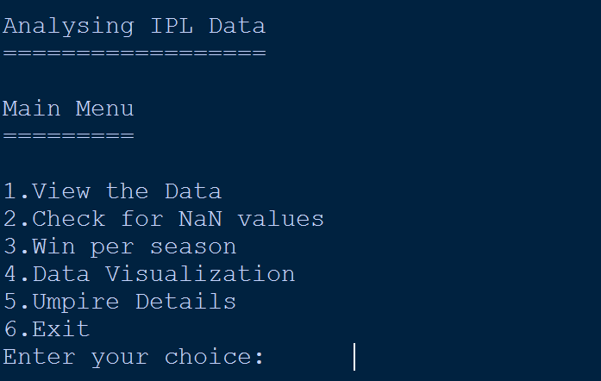

7.2 CSV FILE

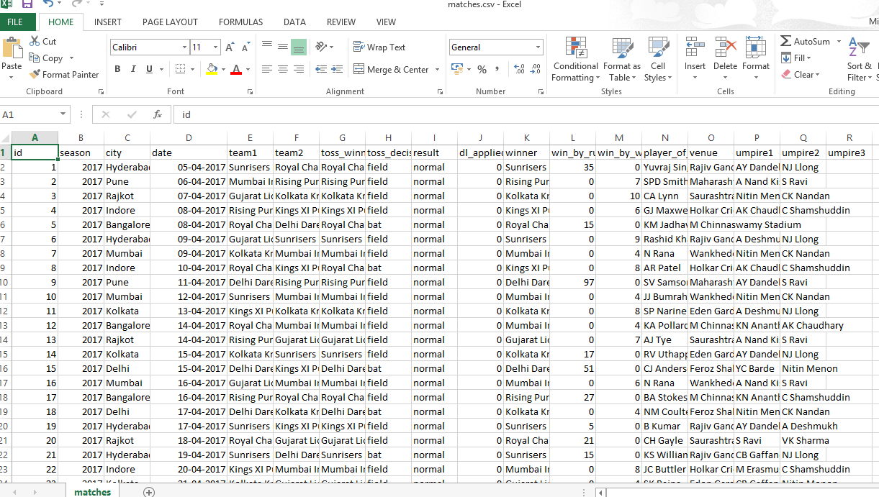

7.3 DATAFRAME DISPLAYED FROM CSV

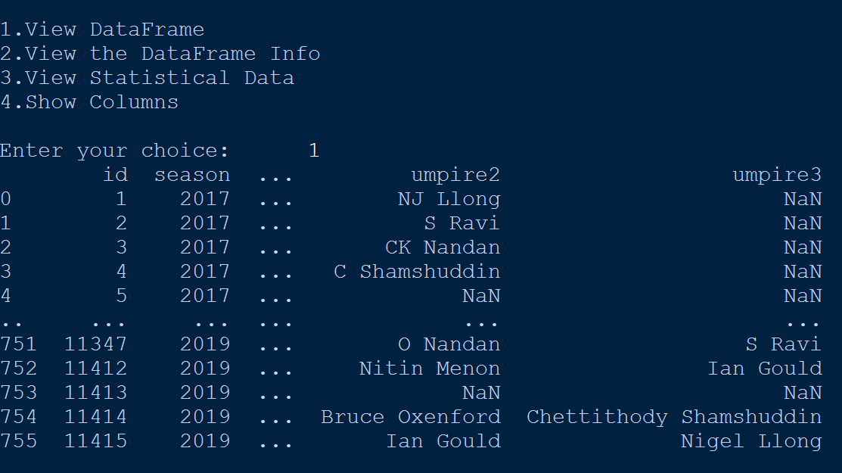

7.4 RUN-TIME SAMPLE OUTPUT WINDOWS

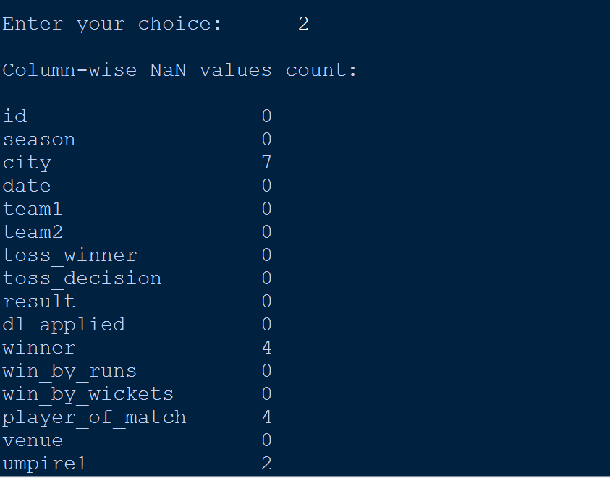

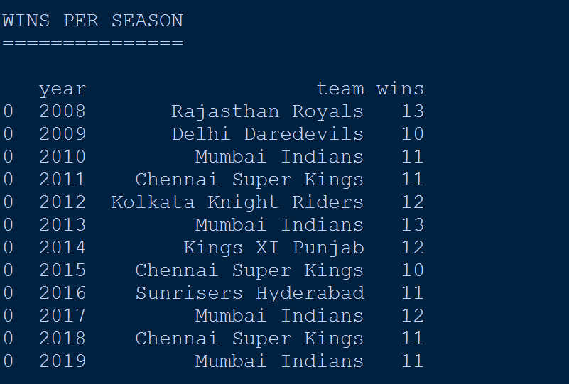

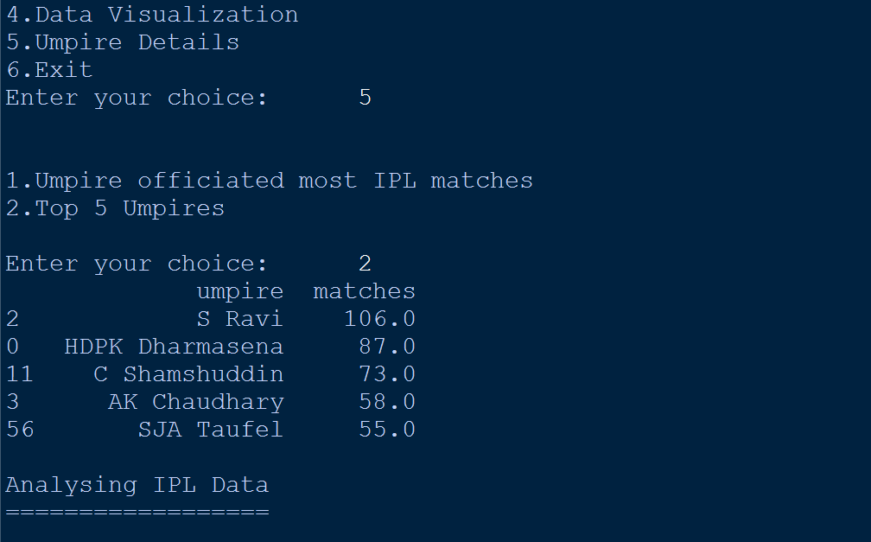

7.5 OUTPUT CHART

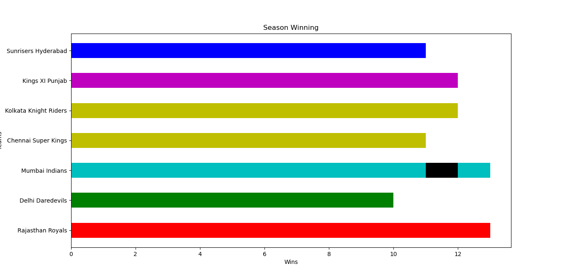

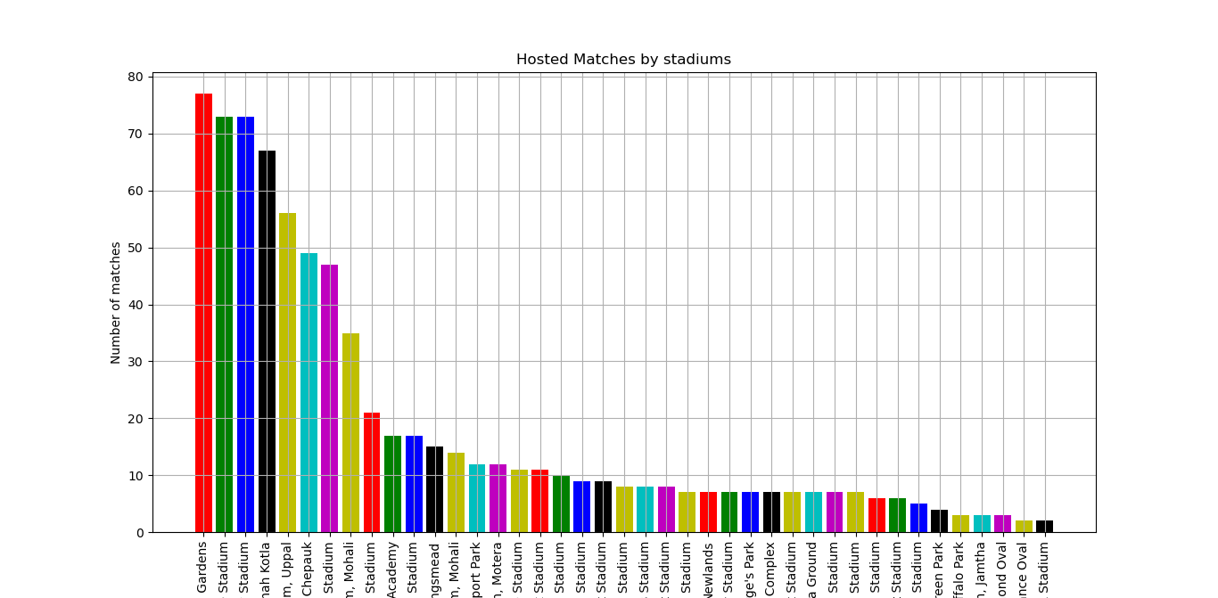

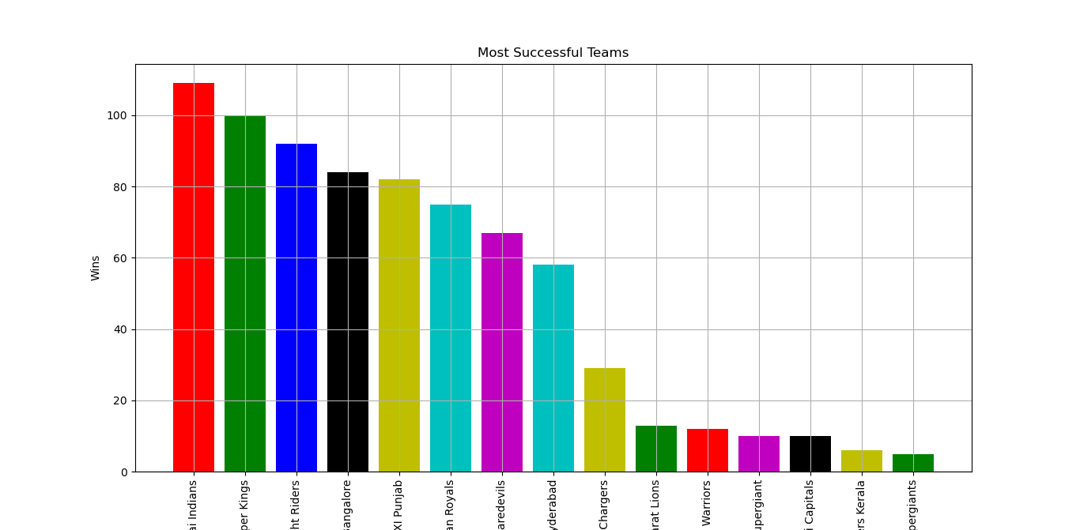

CHAPTER 8
CONCLUSION

Data Science / Analytics is all about finding valuable insights from the given dataset. In short, finding answers that could help business. This program is used to analyse the data store in a csv file using Python’s DataFrame and visualization techniques by matplotlib, specifically related to IPL data. The program generates bar graph based on the choice given by user. Using the method, the data related to the I.P.L can be processed to obtain the details like win per season by each team, Umpire details, visualizing the matches played in each venue, finding out number of matches won by each team season-wise and also the wins per team.

The program can be used in general analysis and determining the success rate by each team. It also tells venue factor in winning the matches in each season. That tells us two things: Python Expressions are very crispy in terms of its syntax and the second thing is, it does not need tens or hundreds of lines to bring out a valuable insight — just a few lines could do the magic — if you’re asking the right question!

CHAPTER 9
REFERENCES

- Informatics Practices - Class XII By : Sumita Arora

- Website: https://www.w3resource.com

- Website : https://pandas.pydata.org/pandas-docs/stable/reference/api/pandas.read_csv.html

- Website : www.python.org

